

**(Annexure A)**

# PROJECT REPORT

## On

**Website and Application for online learning**

## COMPUTER SCIENCE AND ENGINEERING

## **B.E.**

**Batch-2018**

**in**

**December-2020**

|  |
| --- |
|  |

|  |  |
| --- | --- |
| **Under the Guidance of:** | **Submitted By:** |
| Mr. Rinku Saini | **Vanshika Mehta** |
|  | **Id. No. 1810992018** |
|  | **Shreya Sharma** |
|  | **Id. No. 1810991398** |
|  | **Gurleen Kaur Malhotra** |
|  | **Id. No. 1810991992** |
|  | **Gunveer Kataria**  **Id. No. 1810992008** |
|  | **Lakshay Sharma** |
|  | **Id. No. 1810992011** |

**DEPARTMENT OF COMPUTER SCIENCE & ENGINEERING**

**CHITKARA UNIVERSITY**

**PUNJAB**



**(Annexure –B)**

**CERTIFICATE**

This is to be certified that the project entitled “Website and application for online learning” has been submitted for the Bachelor of Computer Science Engineering at Chitkara University, Punjab during the academic semester July 2020-December 2020 is a bonafide piece of project work carried out by “Vanshika Mehta-1810992018, Shreya Sharma-1810991398, Gurleen Kaur-1810991992, Gunveer Kataria-1910992008, Lakshay Sharma-1810992011” towards the partial fulfillment for the award of the course Professional Practices-Cloud Computing & Security using AWS(CS254G) under the guidance of “Mr.Rinku Saini” and supervision.

### Signature of Project Guide:

Mr.Rinku Saini (Assistant Professor | Computer applications

Co-ordinator | Student mentorship Cell)

# (Annexure –C)

**CANDIDATE’S DECLARATION**

We, **Vanshika Mehta-1810992018, Shreya Sharma-1810991398, Gurleen Kaur-1810991992, Gunveer Kataria-1910992008, Lakshay Sharma-1810992011,** B.E.-2018 of the Chitkara University, Punjab hereby declare that the “Cloud Computing & Security using AWS(CS254G)” Report entitled **“**Website and application for online learning**”** is an original work and data provided in the study is authentic to the best of our knowledge. This report has not been submitted to any other Institute for the award of any other course.

|  |  |  |
| --- | --- | --- |
| **Sign. of Student 1** | **Sign. of Student 2** | **Sign. of Student 3** |
| Vanshika Mehta | Shreya Sharma | Gurleen Kaur |
| ID No:1810992018 | ID No:1810991392 | ID No:1810991992 |

|  |  |
| --- | --- |
| **Sign. of Student 4** | **Sign. of Student 5** |
| Gunveer Kataria | Lakshay Sharma |
| ID No:1810992008 | ID No:1810992011 |

|  |
| --- |
| **Place:**Rajpura  **Date:**19th December,2020 |

### 

|  |
| --- |
|  |

**ABSTRACT/ KEYWORDS**

Online learning has proved itself to be the lifesaver for students in this time. Amidst this pandemic most students have shifted towards online learning. Classes conducted in the institutions are more focused towards learning at the same time and providing material for revision for the same while Courses which are put online are more focused towards self-paced learning. It helps provide flexible hours for the students to learn and helps them gain a global and broader perspective. It provides filtered material for students to learn. Hence, we created a website for the students to be at ease while learning the best content offered online for their subject.

Following are the keywords used:

Online learning

Videos

Pdf’s

NCERT solutions

Instructor

**(Annexure -D )**

**ACKNOWLEDGEMENT**

It is our pleasure to be indebted to various people, who directly or indirectly contributed in the development of this work and who influenced our thinking, behavior and acts during the course of study.

We express our sincere gratitude to all for providing an opportunity to undergo “Course Name”- Project as the part of the curriculum.

We are thankful to “Mr.Rinku Saini” for his/her support, cooperation, and motivation provided to us during the training for constant inspiration, presence and blessings.

We also extend our sincere appreciation to ***“Mr.Rinku Saini”*** who provided his/her valuable suggestions and precious time in accomplishing our project report.

Lastly, We would like to thank the almighty and our parents for their moral support and friends with whom we shared our day-to-day experience and received lots of suggestions that improve our quality of work.

|  |  |  |
| --- | --- | --- |
| **Vanshika Mehta** | **Shreya Sharma** | **Gurleen Kaur** |
| **ID No:1810992018** | **ID No:1810991398** | **ID No:1810991992** |

|  |  |
| --- | --- |
| **Gunveer Kataria** | **Lakshay Sharma** |
| **ID No:1810992008** | **ID No:1810992011** |

**INTRODUCTION TO THE PROJECT**

1. **Background**

E-learning has gained great popularity since its emergence in the 1950’s. Projectors and television based learning were the concepts popular back then and while in the 1960’s University of Illinois used e-learning as a concept to teach students through the mode of network connected computers. Reaching the 1990’s distance online learning became a concept and hence since then online learning has been booming aided by the widespread availability of high speed internet and soon to be coming 5G internet. Keeping this in mind and we came across a problem which we as a team decided to solve.

1. **Problem Statement**

Nowadays, it is more preferable to sit home and study online rather than going out to institutions/schools for gaining education. So we designed a website for students who have keen interest in studying and will make most of their time by learning more and more about their respective subjects.

We conducted a survey with the help of our few school & college students. This helped us decide what problems we need to solve and how to attract students of the audience we decided to target at a given point. For the time being the audience targeted are the students of class 9-12 and we tend to further grow ahead and target the students pursuing different streams in their colleges. Based on our survey these were the results we got:

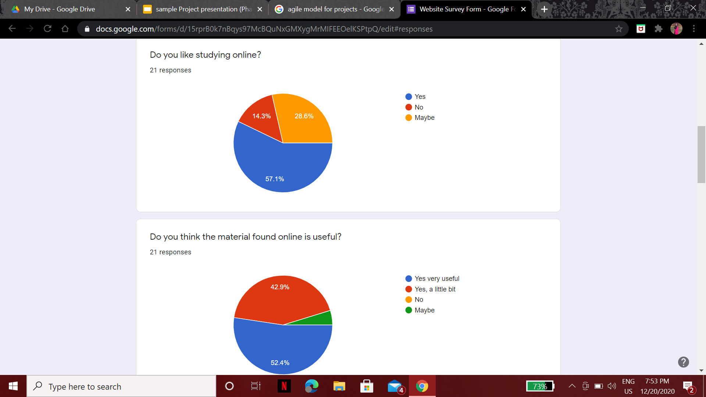

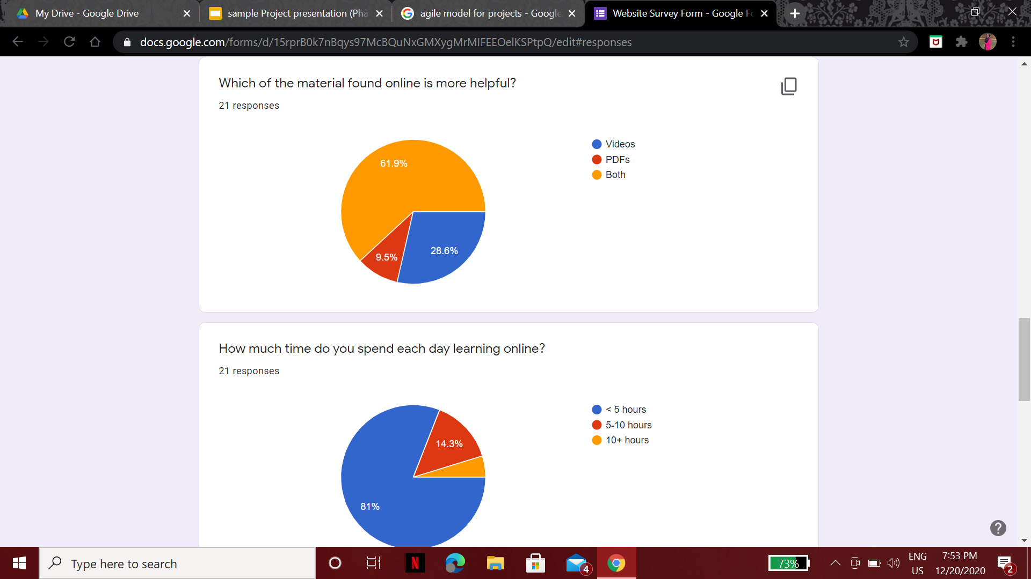

**SOFTWARE AND HARDWARE REQUIREMENT SPECIFICATION**

1. **Methods**

Amazon web Services-**EC2** were used to create/launch a wordpress instance and while it was mapped with elastic IP’s to connect it with our custom domain i.e. **ieducate.co.in.** For the generation of custom nameservers which were used to connect our wordpress instance to our custom domain we used **Route53**. The DNS settings of our custom domain have been changed.

1. **Requirements to run an application**

Hardware such as a mobile laptop/pc etc.

A good internet connection

Windows 7, windows 8, windows, linux and Mac compatible.

**PROGRAM’S STRUCTURE ANALYSING AND GUI CONSTRUCTING**

All the strategy has been put into work and a website has been created.

Further you’ll come across the work done on the backend for the creation of a website.

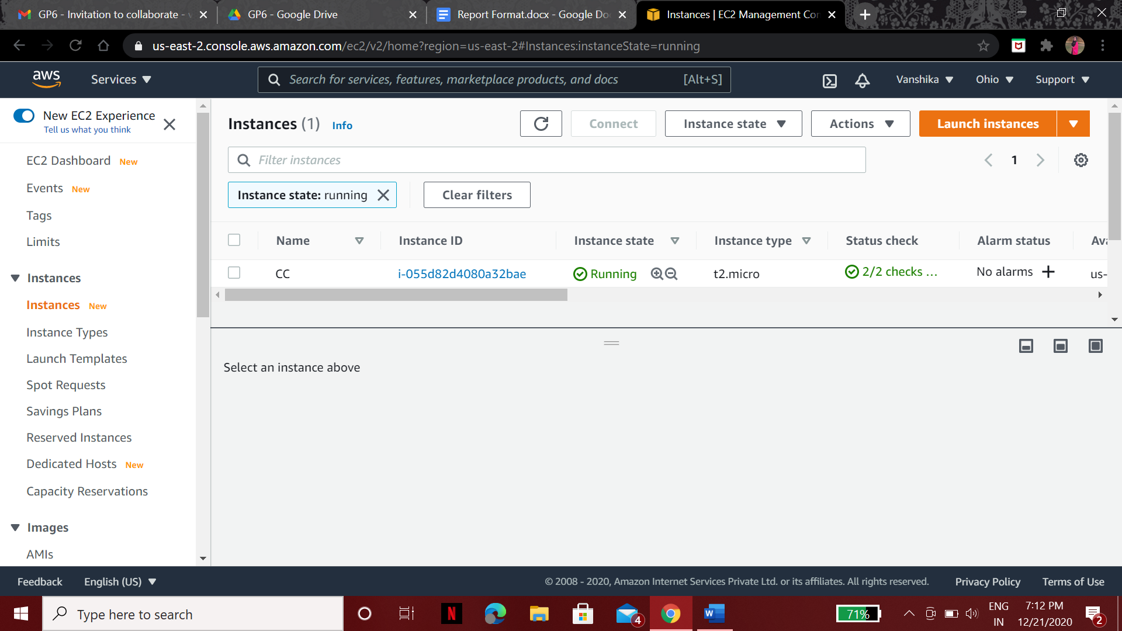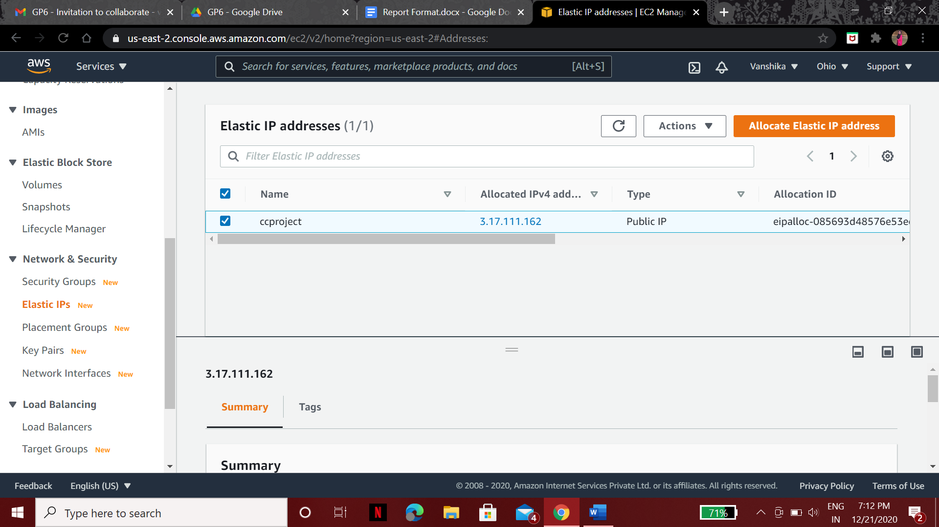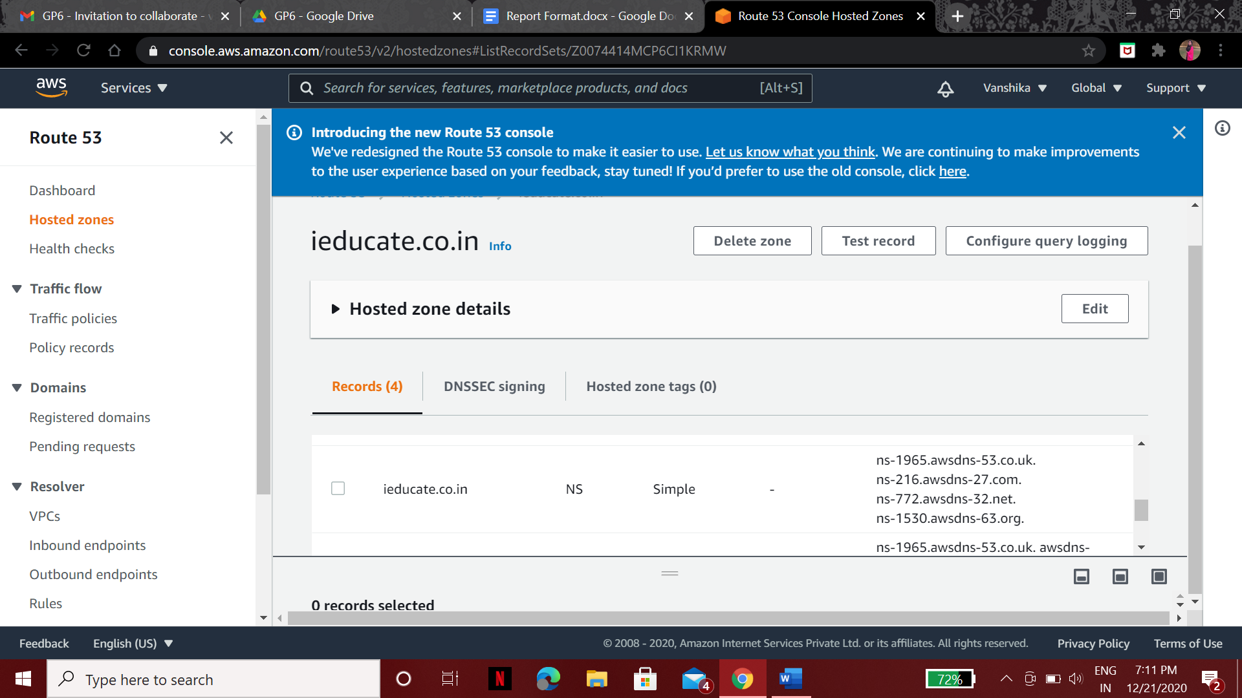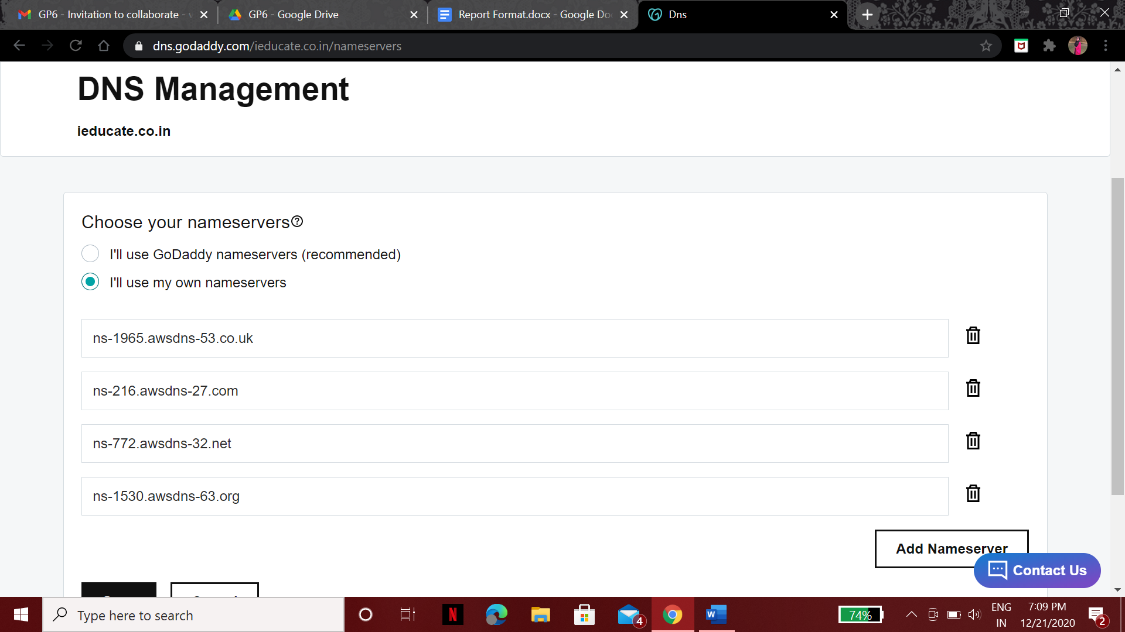

The wordpress website has been created using the Astra theme and elementor.

Total image weight is 432 KB.

Plugins used were Astra Widgets.

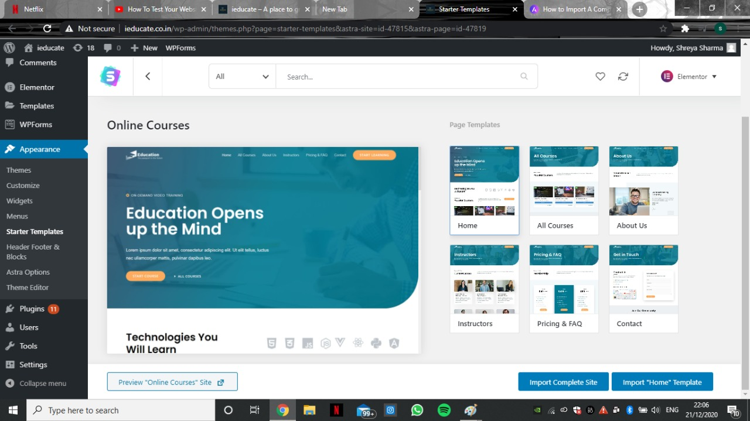

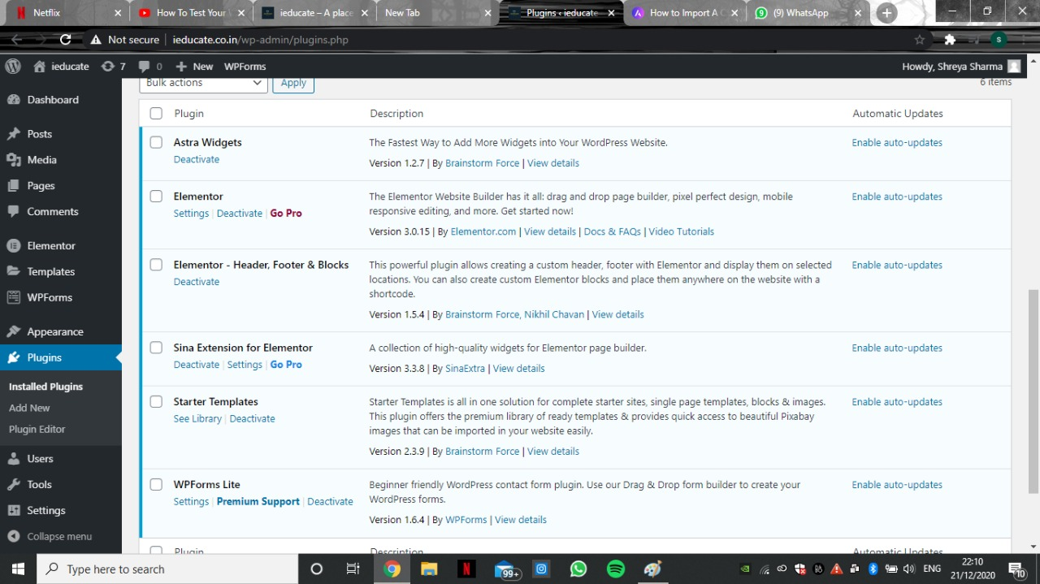

Furthermore you’ll have a look at our website’s final appearance.

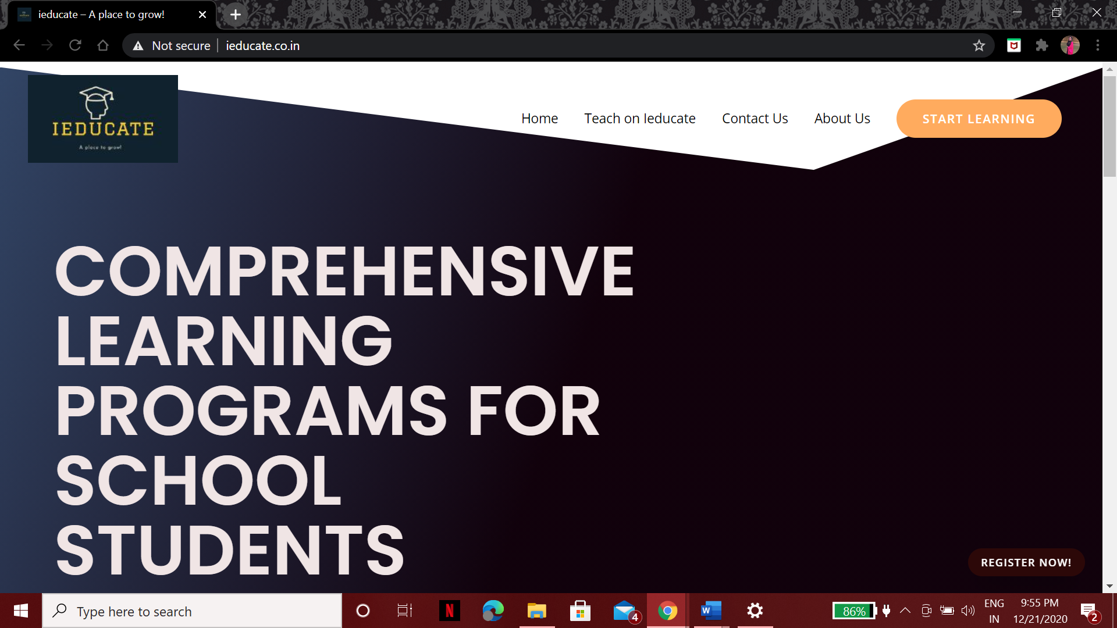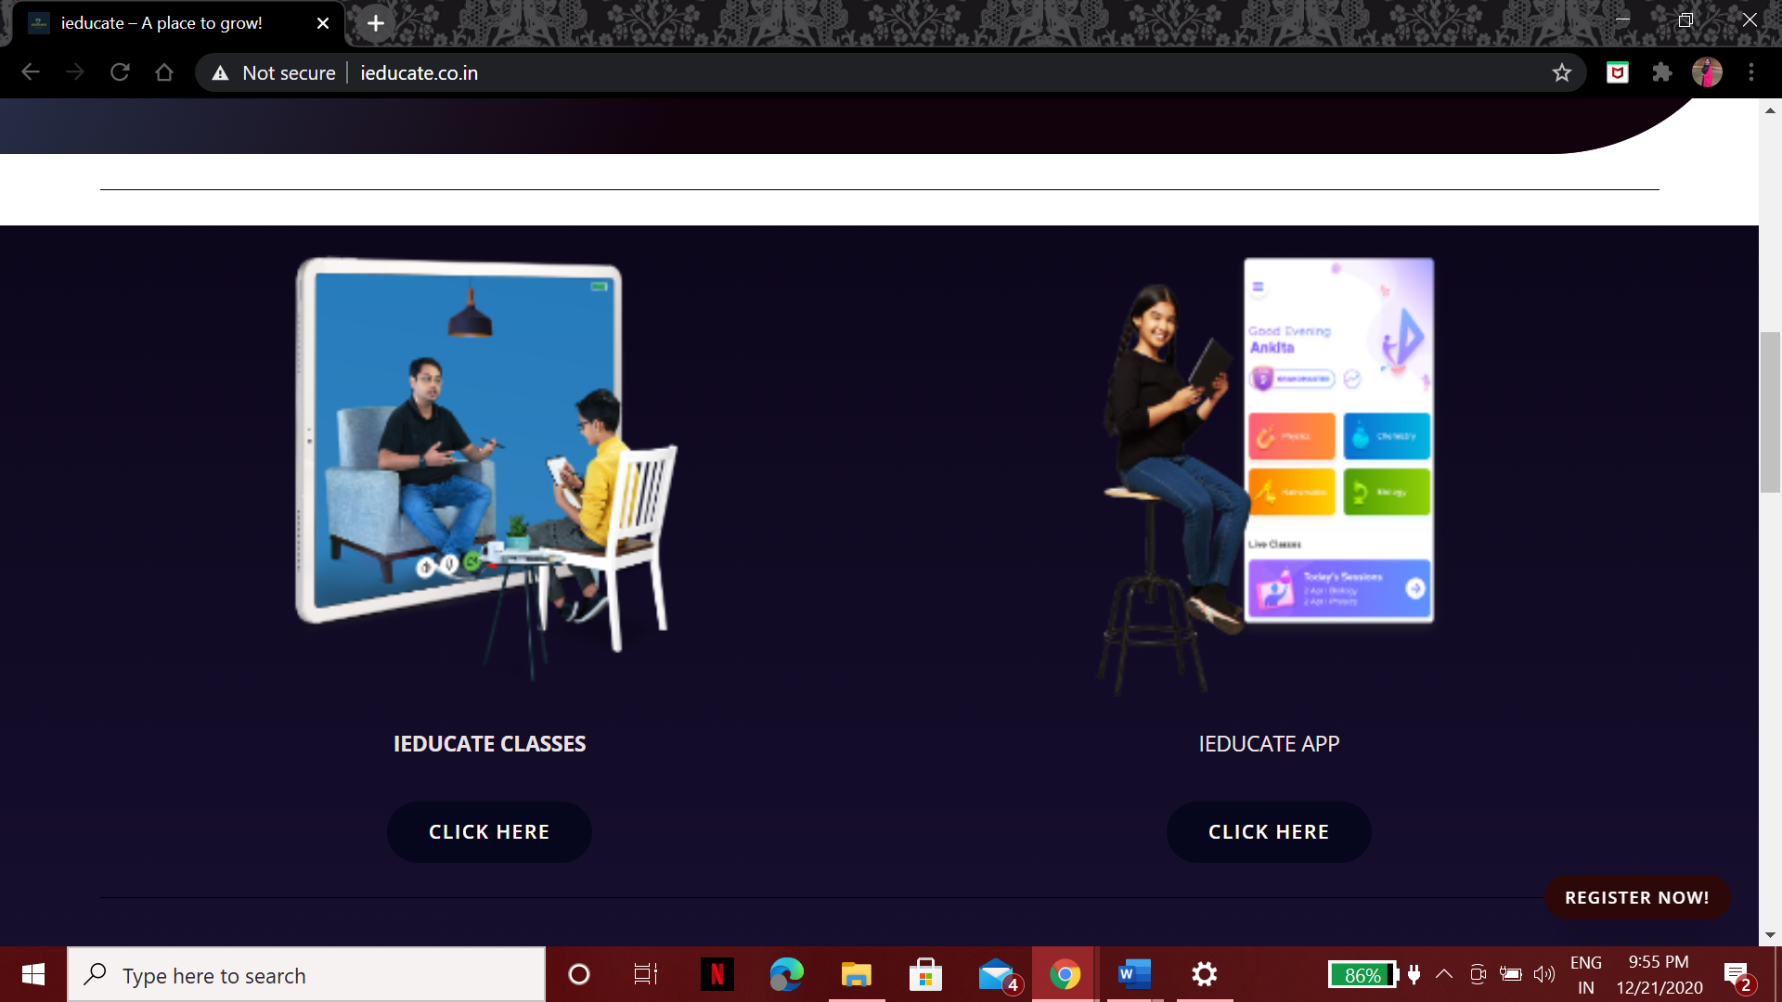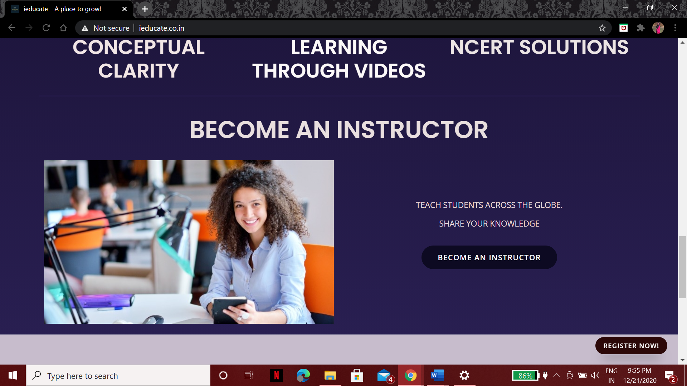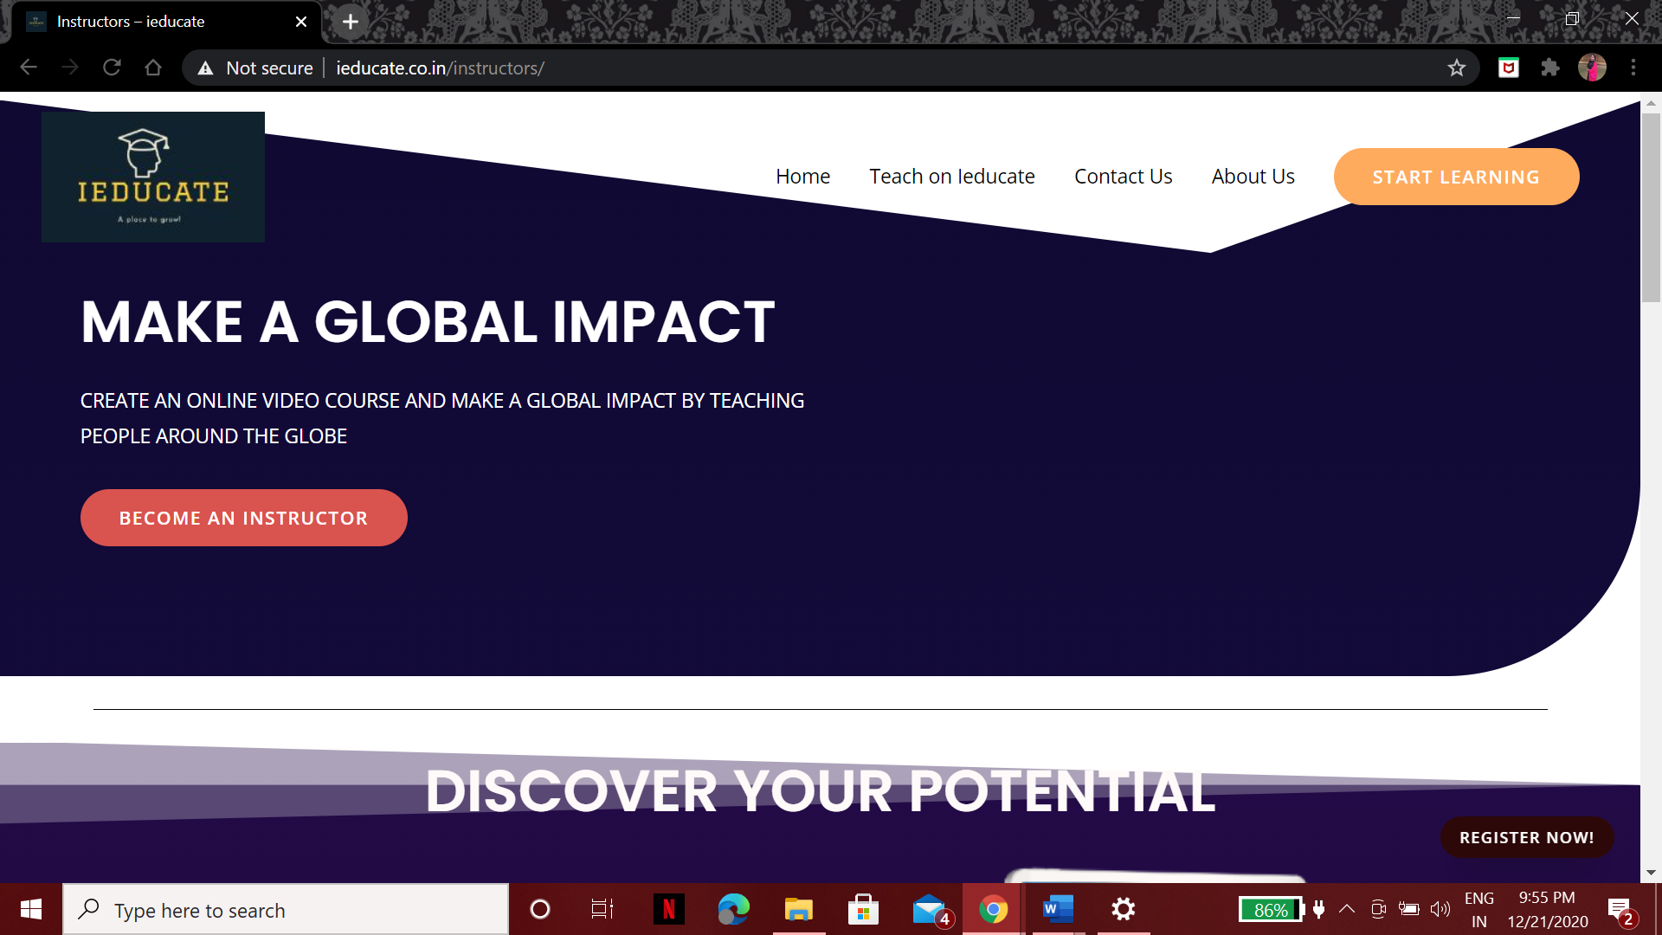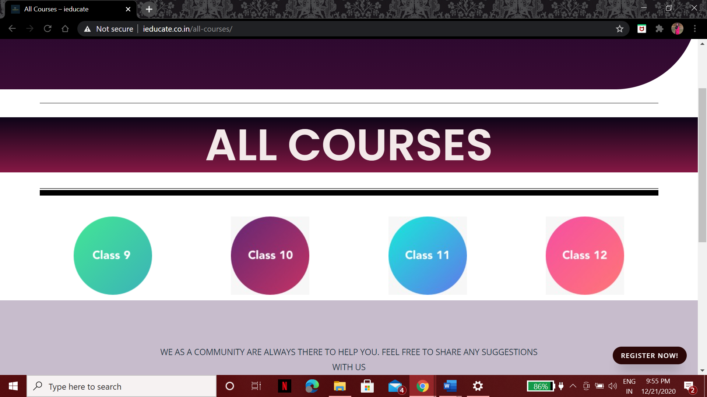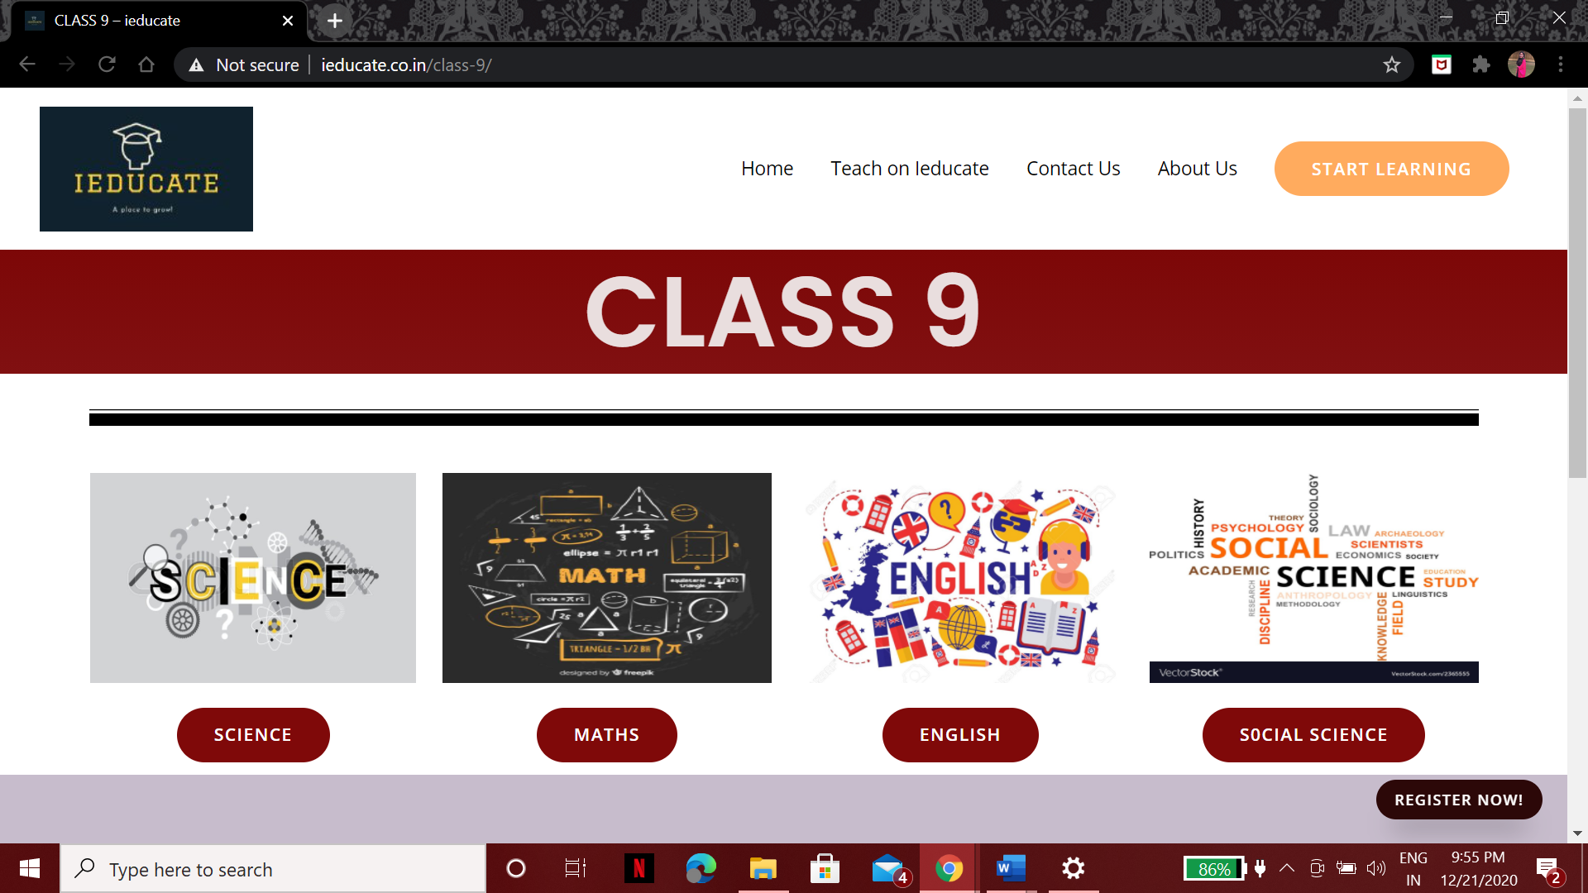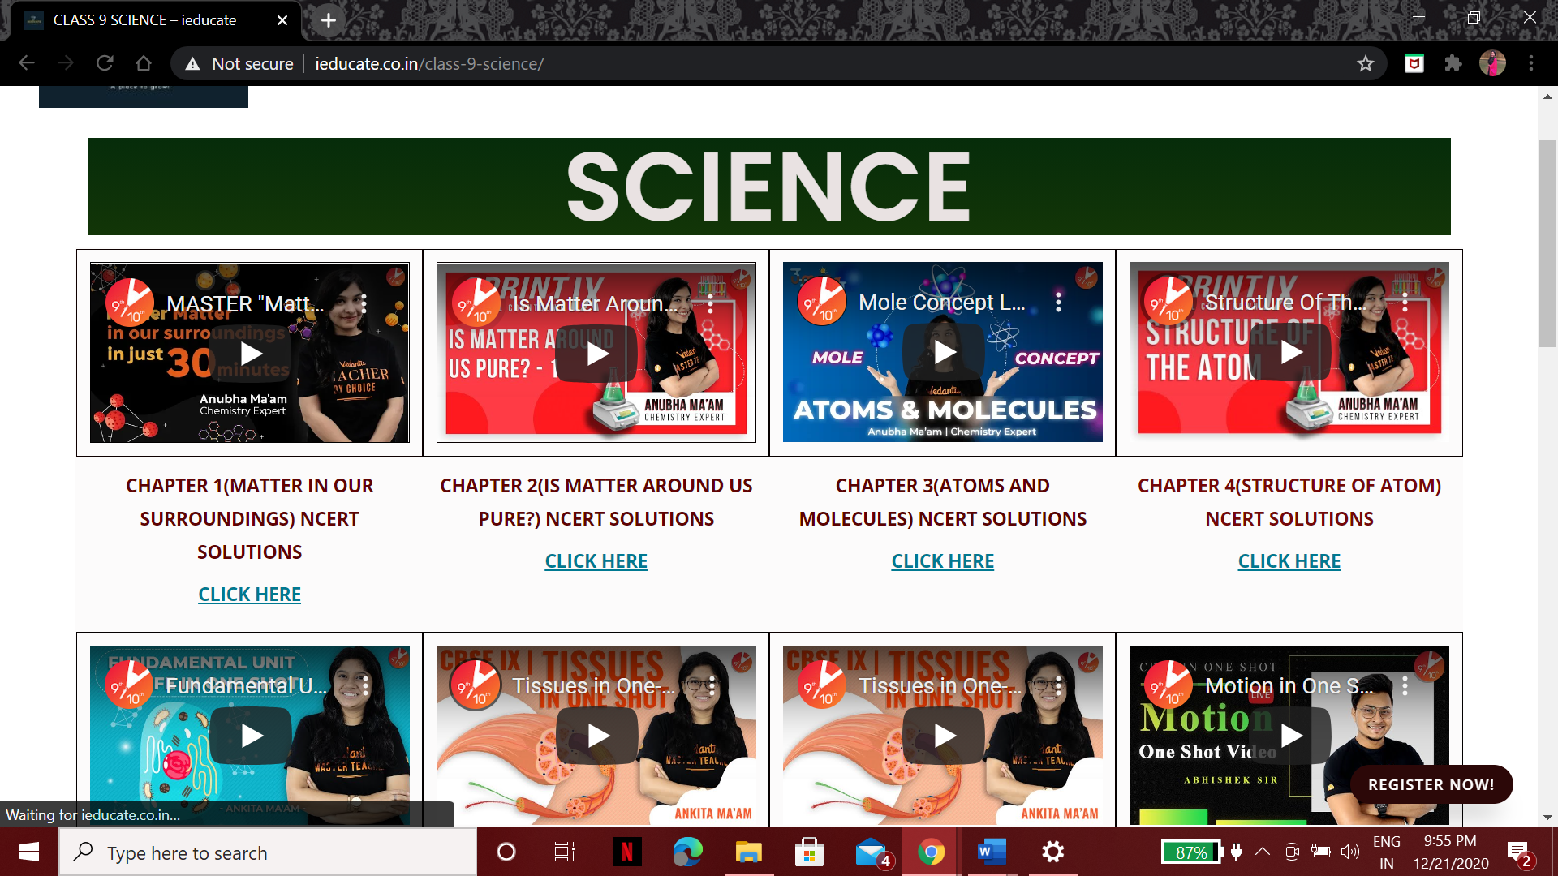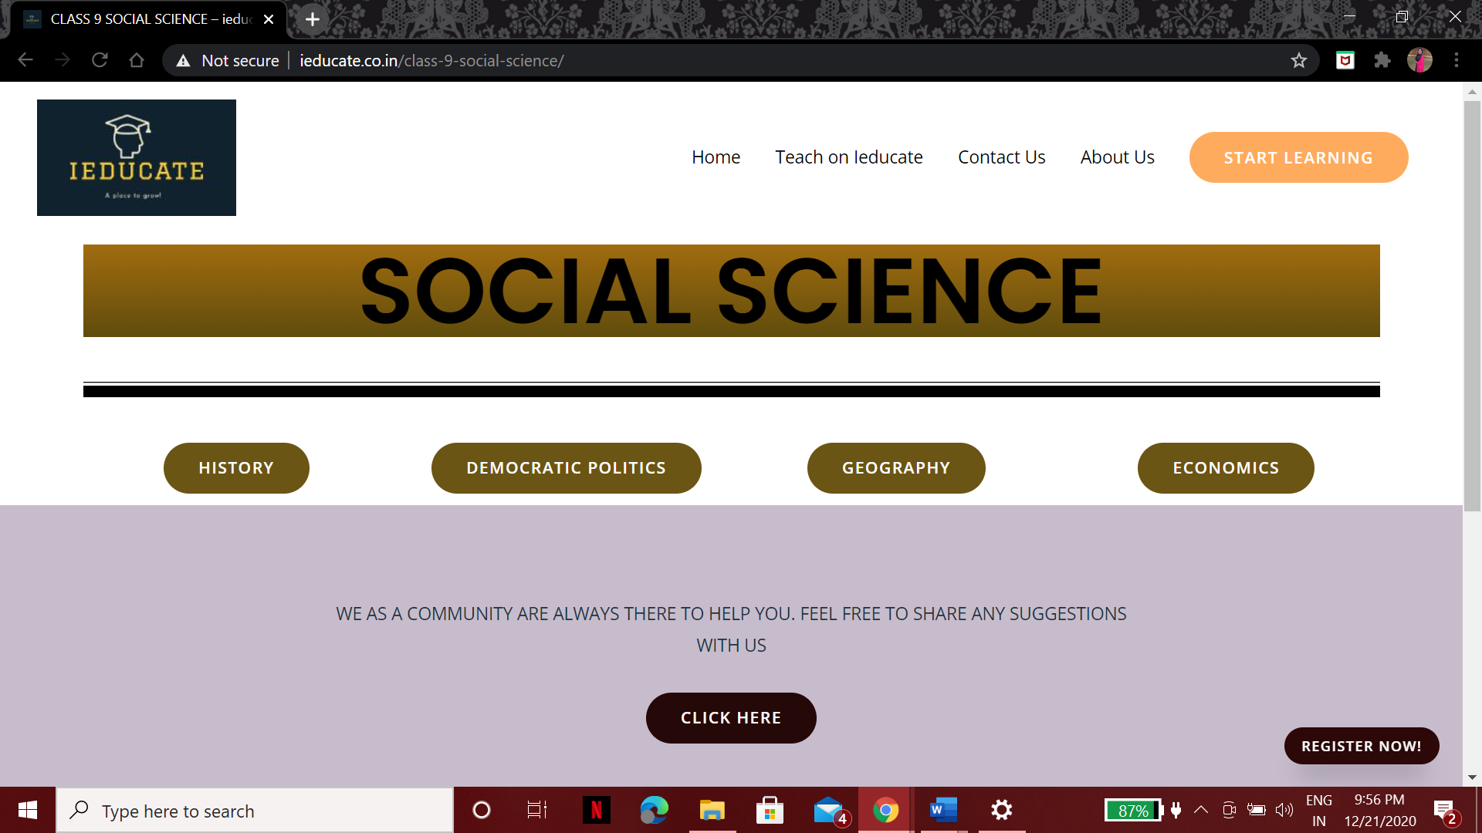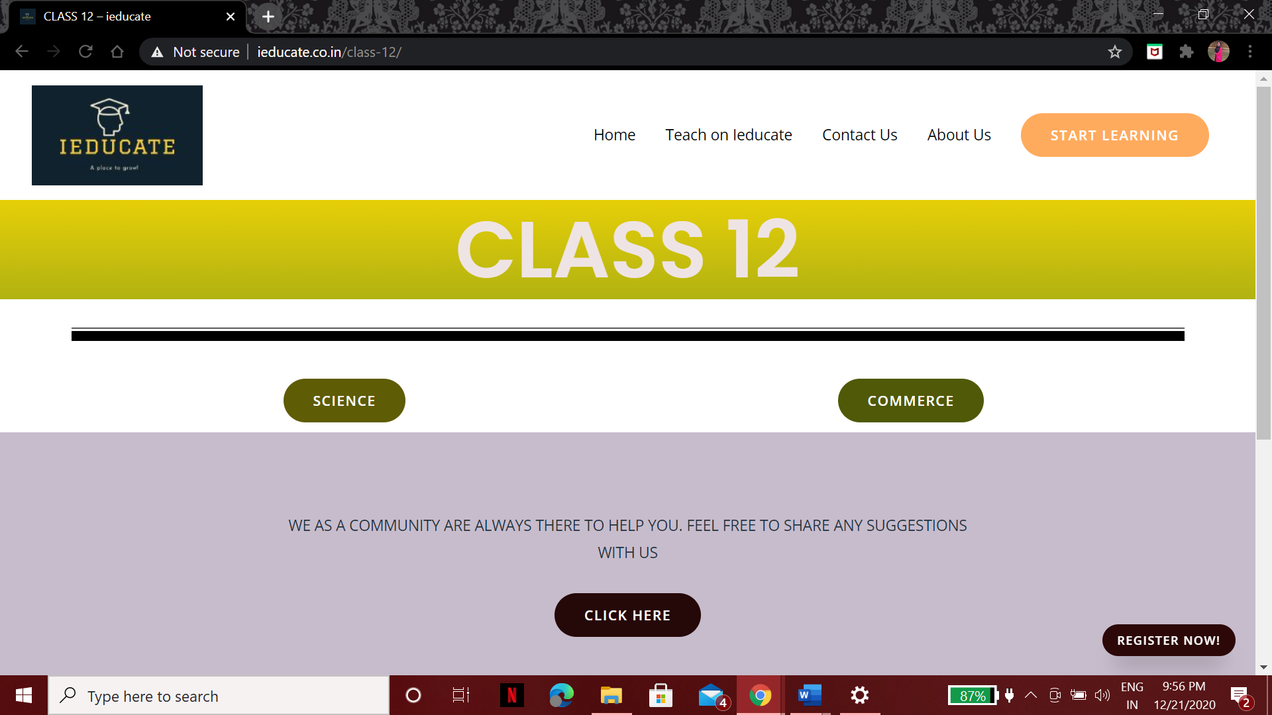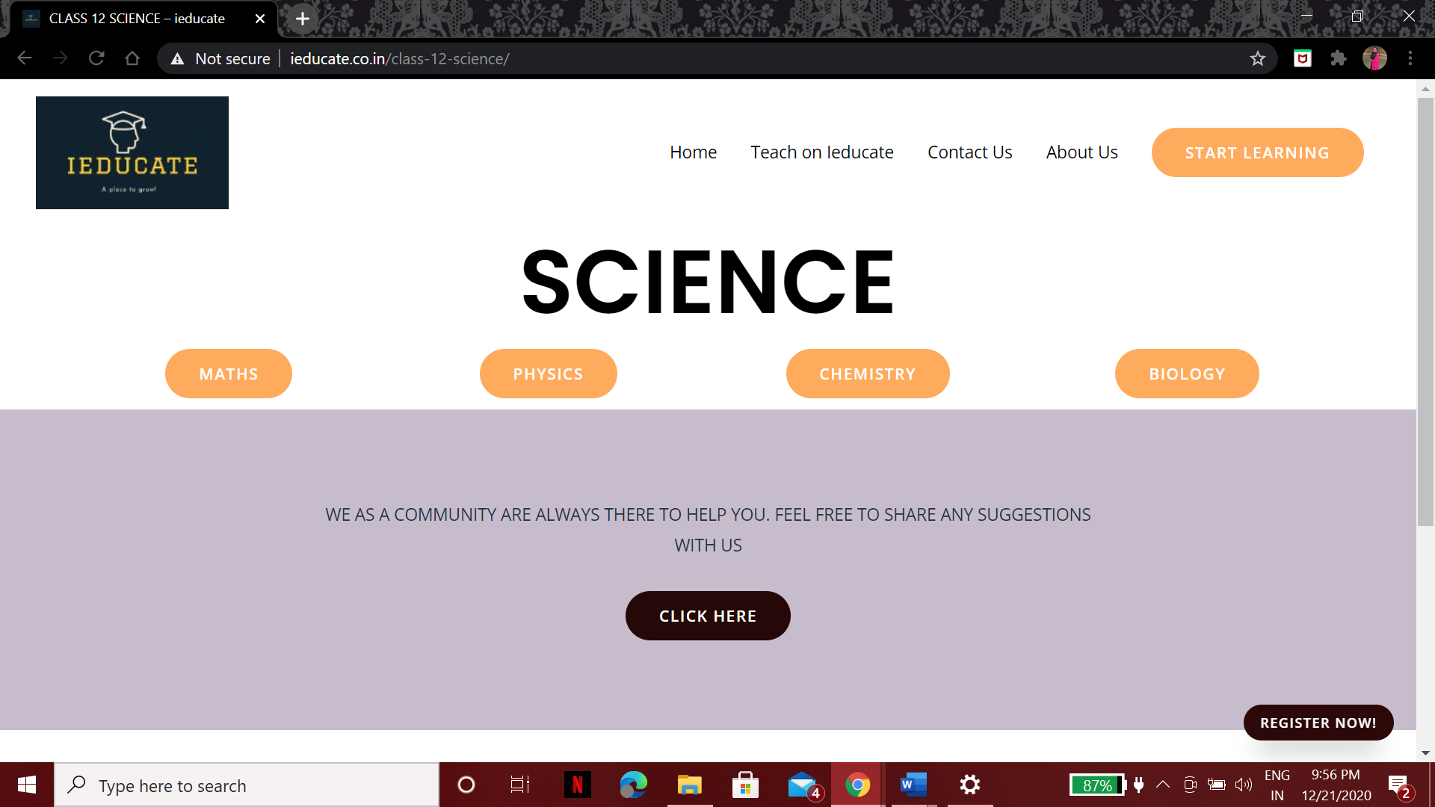

Furthermore you’ll take a look at our mobile application in development.

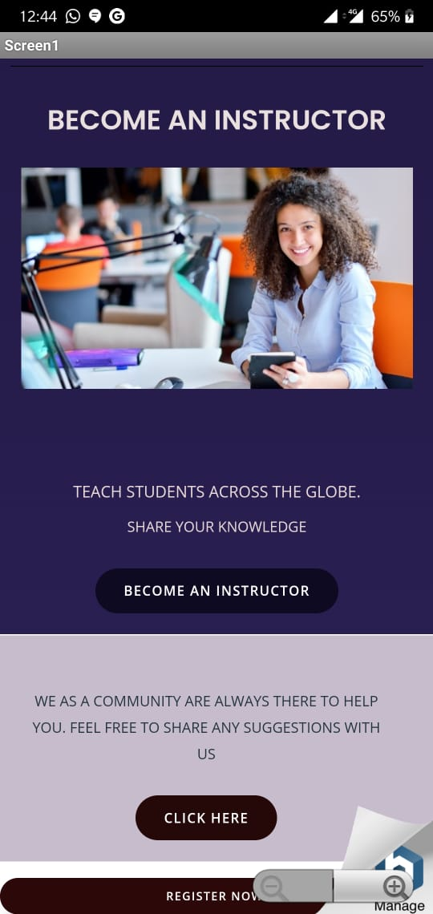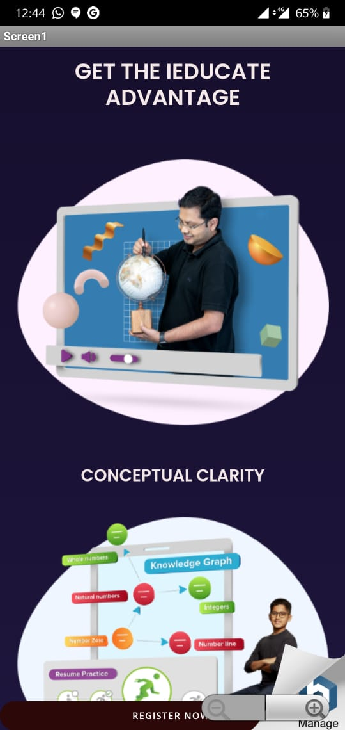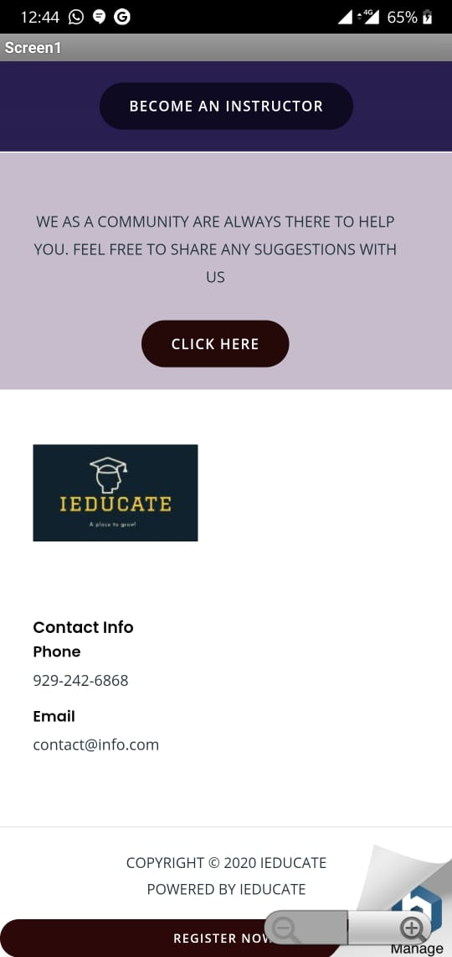

**Specifications of our website**

Our website offers solutions to all the NCERT problems , Video references and last year question papers for all the subjects CHAPTER-WISE for the easy reference and hence makes it easy for the students to learn efficiently.

**Operation of our website**

A new user who enters our website will be allowed to access our website free of cost by registering to our website and try learning more about his/her subject. Furthermore according to their knowledge they will be able to become an instructor if wanted by going through a simple registration process and by giving proof of their needed qualifications.

It is an easy to use website for anyone who has keen interest in studying.

**External Constraints**

There is nothing/ no use of any violent or abusive language. Our website does not promote violence in any way. It is safe for people of all age groups to use.

**LIMITATIONS**

These include limited screen space confines it to work properly on laptops and desktops only for the time being.

**CONCLUSION**

This website would help get the students Video,pdf content filtered by the administrators itself for their learning. It would prove to be a platform for students/ teachers to put their work globally which would in turn help students from across the globe to come forward and interact with their instructors irrespective of time zones. It will be free of cost too.

**FUTURE SCOPE**

We have been more focused towards targeting the right audience at this time and in the future we plan on privatizing our website with the gain in right audience.

**BIBLIOGRAPHY/REFERENCES**

1. <https://youtu.be/cXDFZj1N7KA>
2. <https://www.ubuntupit.com/best-cloud-computing-projects-ideas/>
3. <https://www.skyfilabs.com/blog/top-20-best-cloud-computing-final-year-projects-for-cse-students>
4. <https://www.youtube.com/watch?v=5qxZj-PbAN0>
5. <https://www.youtube.com/watch?v=M34R7u5URcg>
6. <https://www.google.co.in/amp/s/www.cloudways.com/blog/host-wordpress-on-aws-cloud/amp/>
7. <https://youtu.be/MMtCtGhbjmg>